EYFS: Writing Long term Plan
As the EYFS is organised across 7 areas of learning, rather than subjects, it is important to take into account how writing progress is reflected across these areas.
The main areas where writing is related are: Literacy, Communication and Language, Physical development, Expressive Arts and Design.

Writing:
Composition/Writing Spelling Handwriting/Letter Formation
 | Autumn 1 | Autumn 2 | Spring 1 | Spring 2 | Summer 1 | Summer 2
Nursery: 3 and 4 Year olds  Minimum expectation | Marks are the result of gross motor movements.  Random marks going in any direction.  Enjoy drawing freely.  May make marks on their picture to stand for their name. | Beginning to form lines / shapes that represent their name.  May begin to use a grip that they find comfortable when holding pens and pencils. Beginning to improve control over mark making implements.  Drawings / paintings using lines and shapes. Improvement in being able to recognise what the children may be drawing.  Use large-muscle movements to wave flags and streamers, paint and make marks.  Use large-muscle movements to wave flags and streamers, paint and make marks. |  |  | Writes some or all of their name using a letter card or from memory.  Variety of lines and may begin to attempt circular patterns.  Repeated marks on page.  Shows preference for a dominant hand. | Begins transition towards tripod grip.  Use some of their print and letter knowledge in their early writing. For example: writing a pretend shopping list that starts at the top of the page; write ‘m’ for mummy.  Writes all their name using a letter card or from memory.  May write some other letters accurately.  Objects in drawings are recognisable and contain details.  Show different emotions in their drawings and paintings, like happiness, sadness.
Nursery  Squiggle Wiggle and phonics sounds | Up and down movement | upwards / downwards lines | side to side lines | Wavey lines | zig zag lines | arches
Reception (4 to 5)  Minimum Expectation | Composition:  Use talk to link ideas, clarify thinking and feelings.  Write their name by copying it from a name card or try to write it from memory.  May begin to write some initial sounds such as ‘m’ for mum.  Spelling:  Orally segment sounds in simple words, eg c-a-t.  Can say the initial sounds in most words.  Handwriting:  Draws lines and circles.  Can write some recognisable letters from my name | Composition:  Segmenting cvc words and attempting to write them using phonic sounds that have been taught.  May begin to write short phrases with support.  Know there is a sound/symbol relationship.  Write letters and strings, sometimes in clusters like words.  Spelling:  Write own name.  Can identify known letters to match initial sounds  Can match some phase 2 letters and sounds (GPC)  Can write VC and some CVC words and labels e.g. c-a-t.  Handwriting:  Form letters from their name correctly.  Focus on modelling comfortable pen grip.  Beginning to form other recognisable letters from Phase 2 phonics: will be learning the correct route when writing using a handwriting phrase. | Composition:  Can orally compose a caption and hold it in memory before attempting to write it (with support).  Spelling:  Can spell to write VC and CVC words independently using taught Phase 2 graphemes.  Handwriting:  Shows a dominant hand.  Write from left to right and top to bottom. Forming recognisable letters.  Focus on modelling and using the tripod finger grasp when writing, painting, chalking etc.  Able to retrace vertical lines and working on improving anticlockwise movements.  When writing words children are learning to control their letter size.  Children given regular reminders about posture when working at tables: forearms on the table and feet flat on the floor. | Composition:  Writing short captions independently.  May begin to write a simple sentence with support.  Spelling:  Spell to write words independently using Level 1 and some taught digraphs..  Spell some tricky words e.g., the, to etc independently.  Handwriting:  Holds a pencil effectively to form recognisable letters (all lowercase letters).  Is starting to use some capital letters (uppercase) when writing.  Know how to form clear ascenders and descenders.  Focus on developing a comfortable way of writing – tripod pencil grip, position on paper, writing from left to write when writing. Anticlockwise movements focussed; children should be able to retrace vertical lines. | Composition:  Developing the ability to write captions and short sentences independently.  Can read writing back to themselves.  Spelling:  Spell words by drawing on knowledge of known grapheme correspondences.  Make phonetically plausible attempts when writing more complex unknown words.  Handwriting:  Form most lower-case letters correctly, starting and finishing in the right place, going the right way round and correctly orientated.  Can include spaces between words. | Composition:  Write short sentences with words with known letter-sound correspondences using a capital letter and full stop.  Write different text forms for different purposes (e.g., lists, simple stories, instructions.  They can read their own sentences and so can teachers.  Spelling:  Spell words by drawing on knowledge of known grapheme correspondences.  Make phonetically plausible attempts when writing more complex unknown words.  Spell tricky Words e.g., he, she, we, be, me independently.  Handwriting:  Use a pencil confidently to write letters that can be clearly recognised and form some capital letters correctly.  Children may be using finger spaces between their words independently.
Reception phonics sounds taught | S a t p, i, n  M, n, d, g, o, c, k, ck, e, r, u, h, b, f, ff, l, ll, |  | le, ss, j, v, w, x, y, z, zz, qu  ch, sh, th, ng, dge, ve, wh, cks, nk |  | ai, ee (y), igh, (y), oa, oo, oo, ar, or, ur, ow, oi, ear, air, er, er, ue, ue, ure, ture
Reception Handwriting Taught (letter families) | i,l, t, j, u, y, c, o, a, d, g, q, s, e, r, n, m, h |  | h, p, b, k, v, w, f, x, z, capital letters and number formation |  | Capital letters and number formation

Writing Stages
Pre Phonemic Stage
Pictures | Random Scribbling | Scribble writing | Symbols that represent letters | Random letters | Letter Strings | Letter groups
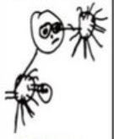 | 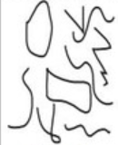 | 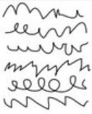 | 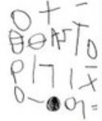 | 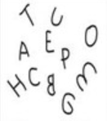 | 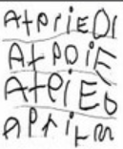 | 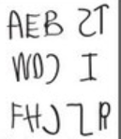
Picture tells a story to convey message | Starting point at any point of paper | Progression is from left to right | Mock letters or symbols |  | Letter strings move from L to R and move down the page | Separated by spaces to resemble different words
Early Phonemic Stage | Letter name stage |  | Transitional Stage
Environmental print  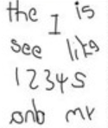 | Beginning sounds  Random and initial consonants  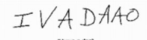 | Initial and final sounds appear  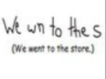  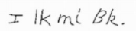 | Vowel sounds appear  Evidence of common exception words  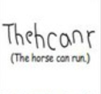  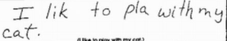 | All syllables represented  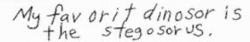 | Inventive spelling  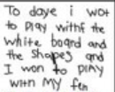 | Multiple related sentences with many words spelled correctly  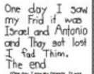  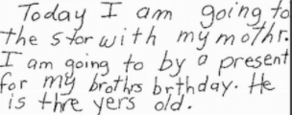
Awareness of print, copied from surroundings. | Beginning and ending letters are used to represent words. |  | Medial sound may initially be written as a consonant.  Vowels begin to appear. | A child hears beginning, middle and end sounds. | Whole sentence writing develops.
Images / research from Heidi Butkus 2014 ©
Pencil Control Development - Development of a tripod grasp
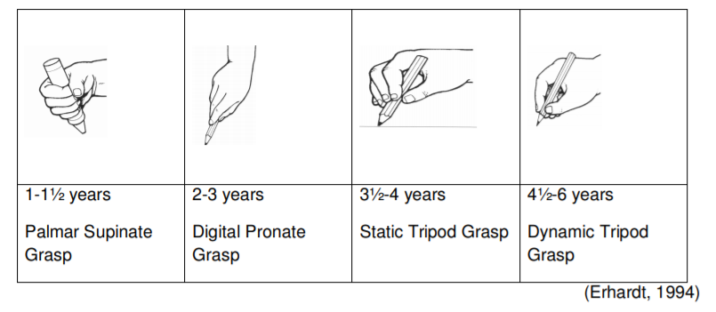
Even when a child has good fine motor skills and well-developed grasp patterns, holding a pencil is a new and complex task. You may need to check the child’s grip on the pencil while they are colouring or drawing. The pictures below show the developmental stages that a child may go through when learning to hold a pen.
A child should be able to use a static or dynamic tripod grasp for writing. This means that: the pencil is held between the tips of the thumb, index and middle fingers the pencil is held in a relaxed way without too much pressure on the shaft of the pencil the pencil rests on the hand between the thumb and index finger (webspace) the webspace gap should be open (ie the thumb and index fingers form a circle) the ring and little fingers are held away from the pencil bent slightly into the palm.

Taken from: Children, Young People and Families Occupational Therapy Team HANDWRITING DEVELOPMENT: NHS
Erhardt, R.P. (1994). Developmental hand dysfunction: Theory, assessment and treatment (2nd Ed.). Tucson, Arizona: Therapy Skills Builders

 | Writing: Transcription Handwriting: letter formation / placement and positioning
Integrated Objectives | Physical Development  3/4 year olds: | Literacy  3/4 year olds:  - Write some letters accurately.  Reception:  - Form lower case and capital letters correctly.  ELG:  - Writes recognisable letters, most of which are correctly formed.
  - Use large-muscle movements to wave flags and streamers, paint and make marks.
  - Use one-handed tools and equipment, for example, making snips in paper with scissors.
  - Use a comfortable grip with good control when holding pens and pencils.
  - Shows a preference for a dominant hand.
  Reception:
  Develop their small motor skills so that they can use a range of tools competently, safely and confidently. Suggested tools: pencils for drawing and writing, paintbrushes.
  - -Use their core muscle strength to achieve a good posture when sitting at a table or sitting on the floor.
  - -Develop the foundations of a handwriting style which is fast, accurate and efficient.
  ELG: Hold a pencil effectively in preparation for fluent writing – using the tripod grip in almost all cases.
 | Writing: Composition: planning, writing and editing
Integrated objectives | Communication and Language:  3/4 year olds:  - Know many rhymes, be able to talk about familiar books, and be able to tell a long story.  Reception:  - Learn new vocabulary.  - Articulate their ideas and thoughts in well-formed sentences.  - Describe events in some detail.  - Use talk to help work out problems and organise thinking and activities. Explain how things work and why they might happen.  - Listen to and talk about stories to build familiarity and understanding.  - Retell the story, once they have developed a deep familiarity with the text; some as exact repetition and some in their own words.  - Use new vocabulary in different contexts.  - Listen to and talk about selected non-fiction to develop a deep familiarity with new knowledge and vocabulary. | Literacy:  3/4 year olds:  - Engage in extended conversations about stories, learning new vocabulary.  - Use some of their print and letter knowledge in their early writing. For example, writing a pretend shopping list that starts at the top of the page; write ‘m’ for mummy.  - Write some or all of their name.  - Write some letters accurately.  Reception:  - Form lower case and capital letters correctly.  - Spell words by identifying the sounds and then writing the sound with the letter/s.  - Write short sentences with words with known letter-sound correspondences using a capital letter and a full stop.  - Re-read what they have written to check it makes sense.  ELG: Writing  Write recognisable letters, most of which are correctly formed. Spell words by identifying sounds in them and representing the sounds with a letter or letters. Write simple phrases and sentences that can be read by others. | Expressive arts and design:  3 / 4 year olds:  - Begin to develop complex stories using small world equipment, like animal sets, dolls and dolls houses, etc.  Reception:  - Develop storylines in their pretend play.  ELG: Being Imaginative and Expressive  - Invent, adapt and recount narratives and stories with peers and teachers.

 | Writing: Transcription Spelling: Spelling Rules
Integrated objectives | Literacy:  3/4 year olds:  - Use some of their print and letter knowledge in their early writing. For example: writing a pretend shopping list that starts at the top of the page; write ‘m’ for mummy. | Literacy:  Reception  - Spell words by identifying the sounds and then writing the sound with the letter/s.  - Write short sentences with words with known letter-sound correspondences using a capital letter and a full stop.

 | Writing: Composition: Awareness of Audience, Purpose and Structure
Integrated objectives | Communication and Language  3 / 4 Year olds  - Use a wider range of vocabulary.  - Be able to express a point of view and to debate when they disagree with an adult or a friend, using words as well as actions.  - Can start a conversation with an adult or a friend and continue it for many turns.  - Use talk to organise themselves and their play: “Let’s go on a bus… you sit there… I’ll be the driver.”  Reception  - Learn new vocabulary.  - Use new vocabulary throughout the day.  - Describe events in some detail.  - Use talk to help work out problems and organise thinking and activities. Explain how things work and why they might happen.  - Develop social phrases.  - Use new vocabulary in different contexts.  ELG: Communication and Language: Speaking  - Participate in small group, class and one-to-one discussion, offering their own ideas, using recently introduced vocabulary.  - Offer explanations for why things might happen, making use of recently introduced vocabulary from stories, non-fiction, rhymes and poems when appropriate.  - Express their ideas and feelings about their experiences using full sentences, including use of past, present and future tenses and making use of conjunctions, with modelling and support from their teacher.

 | Writing: Vocabulary, Grammar and Punctuation: Sentence Construction and Tense
Integrated objectives | Communication and Language:  3/4 year olds:  - Understand ‘why’ questions, like: ‘Why do you think the caterpillar got so fat?’  - Develop their communication, but may continue to have problems with irregular tenses and plurals, such as ‘runned’ for ‘ran’, ‘swimmed’ for ‘swam’.  - Use longer sentences of four to six words.  Reception  - Learn new vocabulary.  - Use new vocabulary throughout the day.  - Articulate their ideas and thoughts in well-formed sentences.  - Connect one idea or action to another using a range of connectives.  ELG: Communication and Language: Speaking  - Offer explanations for why things might happen, making use of recently introduced vocabulary from stories, non-fiction, rhymes and poems when appropriate.  - Express their ideas and feelings about their experiences using full sentences, including the use of past, present and future tenses and making use of conjunctions with modelling and support from the teacher.
 | Writing: Vocabulary, Grammar and Punctuation: Use of phrases and Clauses
Integrated Objectives | Communication and Language:  3/4 year olds:  - Use longer sentences of four to six words.  Reception  - Articulate their ideas and thoughts in well-formed sentences.  - Connect one idea or action to another using a range of connectives.  ELG: Communication and Language: Speaking  - Express their ideas and feelings about their experiences using full sentences, including the use of past, present and future tenses and making use of conjunctions with modelling and support from the teacher.
 | Writing: Vocabulary, Grammar and Punctuation: Poetry and Performance
Integrated Objectives | Communication and Language  3 / 4 year olds:  - Sing a large repertoire of songs.  - Know many rhymes, be able to talk about familiar books, and be able to tell a long story.  Reception  - Engage in story times.  - Retell the story, once they have developed a deep familiarity with the text; some as exact repetition and some in their own words.  - Learn rhymes, poems and songs. | Literacy  ELG: Literacy: Comprehension  - Demonstrate understanding of what has been read to them by retelling stories and narratives using their own words and recently introduced vocabulary. | Expressive Arts and Design  3 / 4 year olds:  - Take part in simple pretend play, using an object to represent something else even though they are not similar.  - Begin to develop complex stories using small world equipment like animal sets, dolls and dolls houses etc.  - Remember and sing entire songs.  - Sing the pitch of a tone sung by another person (‘pitch match’).  - Sing the melodic shape (moving melody, such as up and down and down and up) of familiar songs.  - Create their own songs, or improvise a song around one they know.  Reception:  - Sing in a group or on their own, increasingly matching the pitch and following the melody.  - Develop storylines in their pretend play.  ELG: Expressive Arts and Design: Creating with Materials  - Make use of props and materials when role playing characters in narratives and stories.  ELG: Expressive Arts and Design: Being Imaginative and Expressive  - Invent, adapt and recount narratives and stories with their peers and their teacher.  - Perform songs, rhymes, poems and stories with others, and (when appropriate) try to move in time to music.
 | Writing: Vocabulary, Grammar and Punctuation: Non Fiction
Integrated objectives | Communication and Language  Reception  - Engage in non-fiction books.  - Listen to and talk about selected non-fiction to develop a deep familiarity with new knowledge and vocabulary.  ELG: Communication and Language: Speaking  - Offer explanations for why things might happen, making use of recently introduced vocabulary from stories, non-fiction, rhymes and poems when appropriate. | Literacy  ELG: Literacy: Comprehension  - Use and understand recently introduced vocabulary during discussions about stories, non-fiction, rhymes and poems and during role play.

