Year A Long-Term Plan and Curriculum Overview
 | Autumn 1  It’s Good to Be Me | Autumn 2  The World Around Us | Spring 1  Adventures Around the World | Spring 2  Stories From Past and Present | Summer 1  Tell Me A Tale | Summer 2 Minibeasts
Possible Themes/Lines of Enquiry | - Colour monster (whole school topic)  - Ourselves  - Families  - Homes around the world  - People who help us  - Autumn  - Fire safety  - Diwali | - Bonfire night  - Remembrance Day  - Antibullying Week  - Light and Dark  - The Nativity  - Christmas Singalong  - Christmas Crafts | - Thank you’s and reflections on Christmas  - Cold Places  - Hot places/ Safari  - Weather  - Ramadan and Eid  - Chinese New Year | - Dinosaurs  - Mother’s Day  - Easter  - Spring | - Jack and the Beanstalk  - 3 Little Pigs  - 3 Billy Goats Gruff  - The gingerbread man  Growing plants  STEM building activities  Floating and sinking  Cooking | - Father’s Day Minibeasts:  - Caterpillars  - Bees  - Ladybirds  - Spiders  - Snails  - Worms  Life Cycles  Local Area
Enrichment and Cultural Capital | Reception Only: Cooking Pumpkin Soup  Harvest Festival  Visits from ‘people who help us’  Autumn walk | Pantomime visit  Christmas singalong  Christmas fair  Christmas dinner  Christmas party  Winter walk | Chinese New Year celebrations and food tasting | Mother’s day assembly  Easter garden making  Easter bonnet parade | Sports day | Visit to the butterfly farm
Core Texts | The colour monster  It’s okay to be different  Once there were giants  All about families  Homes around the world  On every house, on every street  A superhero like you  When I grow up  Clothes line clues to the jobs you do  Pumpkin soup  Little red hen  Percy the park keeper  Ellie the Fire Dog  The best Diwali ever  Dipal’s Diwali  Rama and Sita | Ellie the Fire Dog  Where the poppies now grow  Owl babies  The owl who was afraid of the dark  The nativity and other Christmas stories | Poles apart  Bear snores on  The frozen world  We all went on safari  We’re going on a lion hunt  Catch that chicken  Baby goes to market  Homes around the world  Rameena’s Ramadan  Dragon’s in the City | Harry and his bucket full of dinosaurs  Tyrannosaurus Drip  Dear dinosaur  The street beneath my feet  The Easter story | Jack and the beanstalk  3 little pigs  3 billy goats gruff  The Gingerbread Man | The very hungry caterpillar  Ziggy’s frightening flight  What the ladybird heard  Ahh! Spider!  The snail and the whale  Super worm
Poems | Chop Chop A basket of apples Falling Apples | Leaves are Falling Breezy Weather Cup of Tea | Popcorn I can build a Snowman Pancakes | A Little House Spring Wind Mrs Bluebird | A Little Seed Five Little Peas Pitter Patter | A Little Shell Thunderstorm I have a little Frog
AccessArt Units | Access Art –Night Time Collage  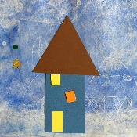 |  | Access Art - Burton Hathow Ducklings  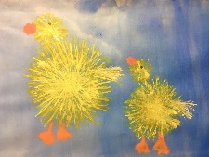 |  | Access Art – insect hotel  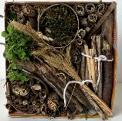
Kapow D&T Units | Kapow D&T Unit – Soup  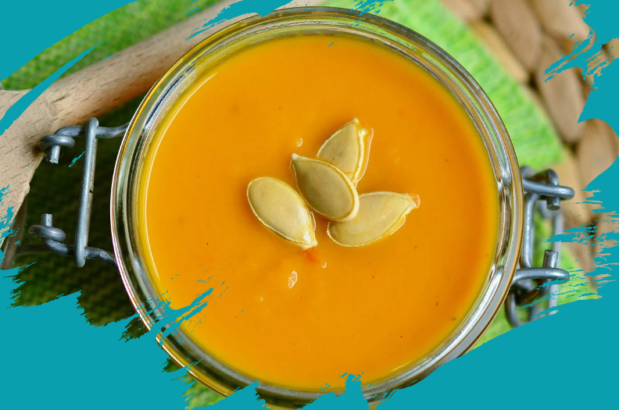 |  | Kapow D&T Unit – Textiles: Bookmarks  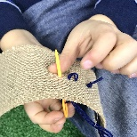 |  | Kapow D&T Unit – Boats  

