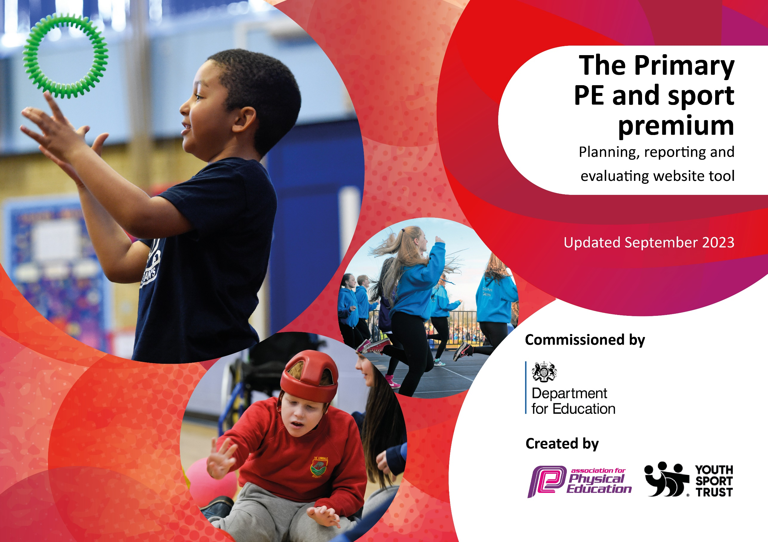

Review of last year’s spend and key achievements (2024/2025)

Activity/Action | Impact | Comments
To increase activity levels during classroom-based teaching time and frequent activity breaks being offered to pupils. | Observations show that after ‘activity breaks’ pupils are more alert and there is an increase of pupils contributing to learning. Pupils enjoy the active breaks and it gives them a boost of energy throughout the day. | Many pupils in our school require movement breaks. These have been streamlined and developed to increase the activity levels during these. We have also begun using sensory circuits for pupils who need these breaks and this has been very successful. Pupils have shown they are able to regulate themselves better after completing these sensory circuits. We will be expanding the use of these throughout the school next year.
Girl power club | Year 5 girl power leaders increasing the physical activity of y3/4 girls. | Year 3, 4 and 5 pupils have enjoyed taking part in girl power this year. Children have developed a life-long love of movement, improved their personal, social, emotional and physical health. Children have a better understanding of mental health and the importance of being active.
Enhance early years outdoor space | Paddock area developed to support and improve the gross motor skills of our early years pupils. | Early years pupils have thoroughly enjoyed using our paddock area this year. The equipment bought has allowed children develop the gross motor skills through running, jumping, crawling, climbing and balancing, strengthening their core and arm muscles. This supports them in sitting on the carpet, sitting at a table and eventually develops their fine motor skills and writing skills.

Key priorities and Planning
This planning template will allow schools to accurately plan their spending.

Action – what are you planning to do | Who does this action impact? | Key indicator to meet | Impacts and how sustainability will be achieved? | Cost linked to the action
Introduce lunchtime sport sessions/activities for pupils including football, running club, girl power | Lunchtime supervisors / teaching staff, coaches - as they need to lead the activity  pupils – as they will take part. | Key indicator 2 -The engagement of all pupils in regular physical activity – the Chief Medical Officer guidelines recommend that all children and young people aged 5 to 18 engage in at least 60 minutes of physical activity per day, of which 30 minutes should be in school.  Key indicator 4: Broader experience of a range of sports and activities offered to all pupils. | More pupils meeting their daily physical activity goal, more pupils encouraged to take part in PE and Sport Activities. | £4000 lunchtime coaches  £1500 extra teaching time for staff to lead sessions  £1000 extra lunchtime equipment to extend range of activities available
Attend more events run by South Solihull Sports Partnership and celebrate these in assemblies. | PE leads – attending and organizing the events.  Pupils – as they will take part | Key indicator 3 - The profile of PE and sport is raised across the school as a tool for whole school improvement  Key indicator 4 - Broader experience of a range of sports and activities offered to all pupils  Key indicator 5 - increased participation in competitive sport | More pupils encouraged to take part in PE and Sports events (both compete and engage). Supports pupils who enjoy going to events but are not competitive. | £2570 SSSP  £2000 transport
PE Leads informed on curriculum, OFSTED and national updates; ensure health & safety requirements are up to date and being met . | PE leads – attending the CPD days held by South Solihull Sports Partnership, to network and peer coach with PE Leads across the Borough. | Key indicator 1 - Increased confidence, knowledge and skills of all staff in teaching PE and sport | PE leads more knowledgeable of updates to share with colleagues at school. | £1500 cover costs and CPD training for others  £1000 H&S
Develop the curriculum using Primary PE Planning to ensure topics have sufficient progression. | All staff – need to be kept informed of new topics taught and trained in how to adapt plans to ensure maximum progress between year groups. | Key indicator 1 - Increased confidence, knowledge and skills of all staff in teaching PE and sport | Staff more knowledgeable of the skills taught and how to develop these when teaching the same lesson to a different year group. | £2000 training for new staff  £2000 general equipment

Key achievements 2024-2025
This template will be completed at the end of the academic year and will showcase the key achievements schools have made with their Primary PE and sport premium spending.

Activity/Action | Impact | Comments
Introduce lunchtime sport sessions/activities for pupils including football, running club, girl power and shooting stars girl’s football  We have had many sporting achievements over the year:  - Girl Power Programme  - Netball League  - Football League  - Chance 2 Shine – school games award  - Quad Kids  - Cheerleading  - Lunchtime clubs – football with FDS coach, girl power  - Girl’s football | More pupils meeting their daily physical activity goal, more pupils encouraged to take part in PE and Sport Activities. | - More pupils have met their daily physical activity goal  - More pupils have been encouraged to take part in PE and Sport Activities.  - Children have developed a life-long love of movement  - Pupils have developed their personal, social, emotional and physical health.  - Children have a better understanding of mental health and the importance of being active.  - Children have developed teamwork skills  - Children have developed skills in new sports such as quick cricket, tri-golf and cheerleading

Swimming Data
Meeting National Curriculum requirements for swimming and water safety.
Priority should always be given to ensuring that pupils can perform safe self-rescue even if they do not fully meet the first two requirements of the National Curriculum programme of study

Question | Stats: | Further context  Relative to local challenges
What percentage of your current Year 6 cohort can swim competently, confidently and proficiently over a distance of at least 25 metres? | 85% | We currently use a pool away from school. The village doesn’t have its own pool so many children only learn to swim through lessons provided at school.
What percentage of your current Year 6 cohort can use a range of strokes effectively [for example, front crawl, backstroke, and breaststroke]? | 64%
What percentage of your current Year 6 cohort are able to perform safe self-rescue in different water-based situations? | 90% | This has improved since pupils in year 5 take lessons and also through learning whilst at residentials in year 4 and 6.
If your schools swimming data is below national expectation, you can choose to use the Primary PE and sport premium to provide additional top-up sessions for those pupils that did not meet National Curriculum  requirements after the completion of core lessons. Have you done this? | No
Have you provided CPD to improve the knowledge and confidence of staff to be able to teach swimming and water safety? | No | Teachers in school do not teach swimming – this is completed by qualified coaches.
Signed off by:

Head Teacher: | Lucy Anderton
Subject Leader or the individual responsible for the Primary PE and sport premium: | Charlotte Taylor and Emily Chapman, PE leaders
Governor: | Rosie Weaver, Chair of Governors
Date: | 14/07/2025

